PROJECT ON
MULTISTOREYED CAR
PARKING SYSTEM

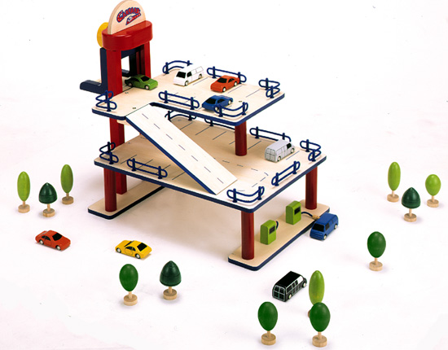
SUBMITTED TO:-
SUBMITTED BY:-

ACKNOWLEDGEMENT
Of all the people who have helped us in making this project we would like to thank them. We gratefully thank god, our teacher Mr. Raushan Kumar, parents and friends.
We would like to thank our sir especially for giving us such an interesting topic to work on and helped, supported us during this project. He has taken pain to go through the project and make necessary corrections as and when needed.
We would also thank our institution and faculty members without whom this project would have been a distant reality.

INDEX
S.NO. | TOPIC | PG.NO.
1. | Abstract | 5
2. | Introduction | 6
3. | Theory of project | 7
4. | Hardware description | 8-10
5. | Main sections in the model | 11-14
6. | Software description | 15-21
7. | Working | 22
8. | Advantages & Disadvantages | 23-25
9. | Application | 26
10. | Bibliography | 27

CERTIFICATE
This is to certify that Name……………………………………… of B.TECH-ECE from …………………………………………………………….. has done his/her six weeks industrial training.
The project work entitled “Microcontroller Based Multistoried Car Parking System” embodies the original work done by the candidate during her above six weeks industrial training period.

Teacher’s signature:
Date:

ABSTRACT
Multi-Storey Car Parking is a method of parking and retrieving cars that typically use a system of pallets and lifts. The intention is to compact more cars in the same space, reduce the space needed to park the same number of cars. Car parks can be situated above or below ground or a combination of both. This makes the system modernized and thus space saving one. This idea was developed using 8051 microcontroller.

INTRODUCTION
Automatic multistoried car parking system helps to minimize the parking area. In the modern world where parking space has become a very big problem, it has become very important to avoid the wastage of space in modern big companies and apartments etc. in places where more than 100 cars need to be parked, this system proves to be useful in reducing wastage of space. This automatic car parking system enables the parking of vehicles, floor after floor and thus reducing the space used. Here any number of cars can be parked according to the requirement. These makes the system modernized and thus space-saving one. This idea is developed using 8051 microcontroller.

THEORY OF PROJECT

A display is provided at the ground floor which is basically a counter which will count the number of cars in each floor and according to that message will be displayed on it. A gate is also provided at the ground floor which is controlled by the stepper motor. Before the gate an IR pair is provided to sense that the car has reached towards the gate. For e.g. suppose a car reaches between the 2 IR pairs, then the LCD will display the particular floor on which car can be parked. As soon as the car crosses the 2nd IR pair, the gate will open automatically. An indicator with green and red led is kept on each floor to indicate whether the car can be parked on that particular floor or not. If green led of any particular floor glows, then it will indicate that the particular floor is empty and you can park your car on that floor. But in case if red led of that particular floor glows, then it will indicate that there is no vacancy on that floor, in such case you can park your car on the next floor according to the indication.
If there is no parking place, then all the red indicators of the floors will glow and the LCD will display “NO SPACE FOR PARKING” and the gate will remain closed.
Program is written using 8051 microcontroller. All the circuits are interfaced with it.

HARDWARE DESCRIPTION:-
Introduction to 8051 Microcontroller:
The first task faced when learning to use a new computer is to become familiar with the capability of the machine. The features of the computer best learned by studying the internal hardware design, also called the architecture of the device, to determine the type, number, and size of the registers and other circuitry.
The hardware is manipulated by an accompanying set of program instructions, or software. One familiar with hardware and software, the system designer can then apply the microcontroller to the problems at hand. In this project we make use of microcontroller. The 8051 microcontroller generic part number actually includes a whole family of microcontrollers that have numbers ranging from 8031 to 8751.The block diagram of the 8051 shows all of the features unique to microcontrollers:
- Internal ROM and RAM
- I/O ports with programmable pins
- Timers and counters
- Serial data communication
The block diagram also shows the usual CPU components program counter, ALU, working registers, and the clock circuits. The 8051 architecture consists of these specific features:
- 8 bit CPU with registers A and B
- 16 bit PC &data pointer (DPTR)
- 8 bit program status word (PSW)
- 8 bit stack pointer(SP)
- Internal ROM or EPROM (8751)of 0(8031)to 4k(8051)
- Internal RAM of 128 bytes.
- 4 register banks , each containing 8 registers
- 80 bits of general purpose data memory
- 32 input/output pins arranged as four 8 bit ports:P0-P3
- Two 16 bit timer/counters:T0-T1
- Two external and three internal interrupt sources
- Oscillator and clock circuits.A pin out of the 8051 packaged in a 40 pin DIP is shown below:-
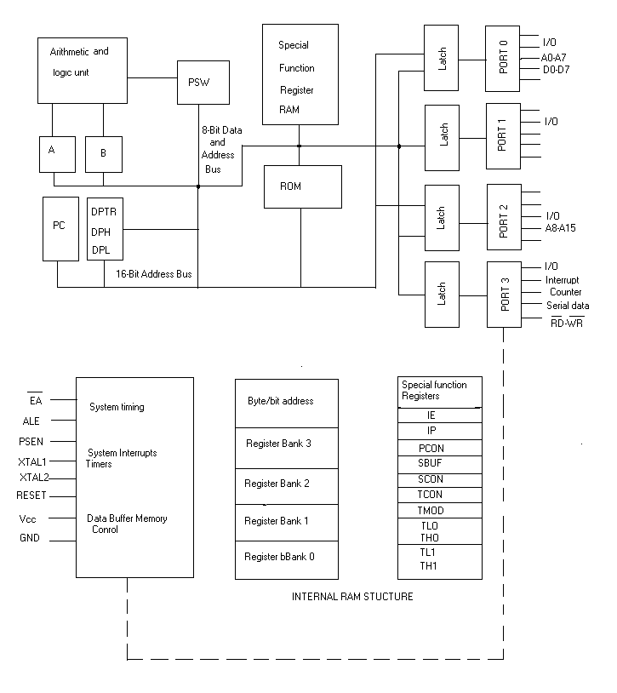

Internal block diagram of IC 8051

A pin out of the 8051 packaged in a 40 pin DIP
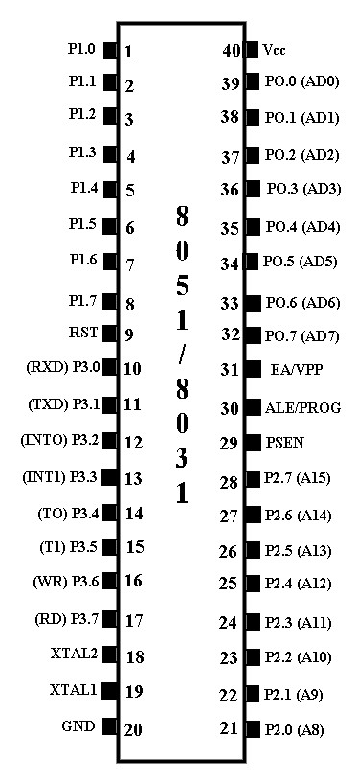

MAIN SECTIONS IN THIS MODEL ARE:-
- Display section.
- Indicator section.
- Sensor section.

- INDICATOR SECTION:-

An indicator section consists of LED.
A light-emitting diode (LED) is a semiconductor light source. LEDs are used as indicator lamps in many devices, and are increasingly used for lighting.
When a light-emitting diode is forward biased (switched on), electrons are able to recombine with holes within the device, releasing energy in the form of photons. This effect is called electroluminescence and the color of the light (corresponding to the energy of the photon) is determined by the energy gap of the semiconductor. An LED is usually small in area, and integrated optical components are used to shape its radiation pattern and assist in reflection. LEDs present many advantages over incandescent light sources including lower energy consumption, longer lifetime, improved robustness, smaller size, faster switching, and greater durability and reliability. LEDs powerful enough for room lighting are relatively expensive and require more precise current and heat management than compact fluorescent lamp sources of comparable output.
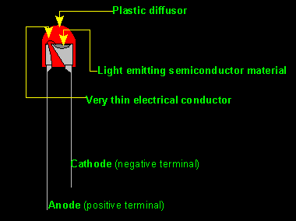

HOW AN LED GLOWS?
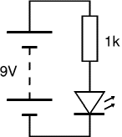
REQUIREMENT IN PROJECT:-
A green and red led are provided on each floor to indicate whether the car can be parked on that particular floor or not.
If green led of any particular floor glows, then it will indicate that the particular floor is empty and you can park your car on that floor. But in case if red led of that particular floor glows, then it will indicate that there is no vacancy on that floor, in such case you can park your car on the next floor according to the indication.
If there is no parking place, then all the red indicators of the floors will glow.

2.SENSOR SECTION:-

A sensor section consists of an IR pairs.
A sensor is a device that measures physical quantity and converts it into a signal which can be read by an observer or by an instrument.
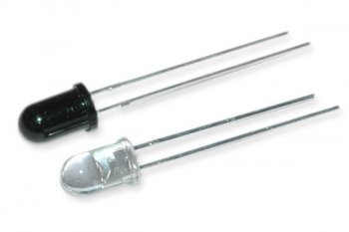
An IR pair is provided which will sense whether the car has reached towards the gate or not. There will be 2 IR pairs provided before the main gate at the ground floor. As soon as the car reaches between the 2 IR pairs. It will be sensed by the sensors and the display on the LCD automatically changes and it will show the particular floor on which the car can be parked.

3.DISPLAY OR LCD SECTION:-
A display section consists of an LCD.
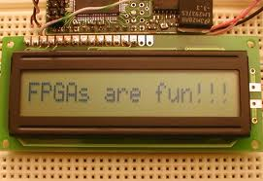

A liquid crystal display (LCD) is a thin, flat electronic visual display that uses the light modulating properties of liquid crystals. LCDs are more energy efficient and offer safer disposal than CRTs. Its low electrical power consumption enables it to be used in battery-powered electronic equipment. It is an electronically-modulated optical device made up of any number of pixels filled with liquid crystals and arrayed in front of a light source (backlight) or reflector to produce images in color.

LCD pin descriptions:
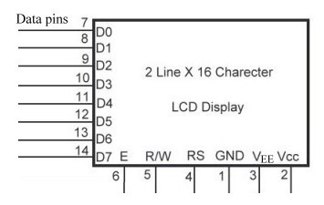
The LCD discussed in this section has 14 pins.

INTERFACING OF 8051 WITH LCD:-
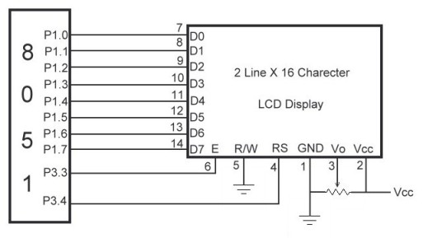
SOFTWARE DESCRIPTION:-
EMBEDDED C:-
The use of C language to program microcontrollers is becoming too common. And most of the time its not easy to buld an application in assembly which instead you can make easily in C. So Its important that you know C language for microcontroller which is commonly known as Embedded C. As we are going to use Keil C51 Compiler, hence we also call it Keil C.

►Keywords:
Keil C51 compiler adds few more keywords to the scope C Language:
_at_ | far | sbit
alien | idata | sfr
bdata | interrupt | sfr16
bit | large | small
code | pdata | _task_
compact | _priority_ | using
data | reentrant | xdata
data/idata:
Description: The variable will be stored in internal data memory of controller.
example:
CODE:
unsigned char data x;
//or
unsigned char idata y;

bdata:
Description: The variable will be stored in bit addressable memory of controller.
example:
CODE:
unsigned char bdata x;
//each bit of the variable x can be accessed as follows
x ^ 1 = 1; //1st bit of variable x is set
x ^ 0 = 0; //0th bit of variable x is cleared
xdata:
Description: The variable will be stored in external RAM memory of controller.
example:
CODE:
unsigned char xdata x;
code:
Description: This keyword is used to store a constant variable in code memory. Lets say you have a big string which is not going to change anywhere in program. Wasting ram

for such string will be foolish thing. So instead we will make use of the keyword "code" as shown in example below.
example:
CODE:
unsigned char code str="this is a constant string";
pdata:
Description: This keyword will store the variable in paged data memory. This keyword is used occasionally.
example:
CODE:
unsigned char pdata x;
_at_:
Description: This keyword is used to store a variable on a defined location in ram.
example:
CODE:
unsigned char idata x _at_ 0x30;
// variable x will be stored at location 0x30
// in internal data memory
sbit:
Description: This keyword is used to define a special bit from SFR (special function register) memory.
example:
CODE:
sbit Port0_0 = 0x80;
// Special bit with name Port0_0 is defined at address 0x80

sfr:
Description: sfr is used to define an 8-bit special function register from sfr memory.
example:
CODE:
sfr Port1 = 0x90;
// Special function register with name Port1 defined at addrress 0x90
sfr16:
Description: This keyword is used to define a two sequential 8-bit registers in SFR memory.
Example:
CODE:
Sfr16 DPTR = 0x82;
// 16-bit special function register starting at 0x82
// DPL at 0x82, DPH at 0x83

Using:
Description: This keyword is used to define register bank for a function. User can specify register bank 0 to 3.
Example:
CODE:
Void function () using 2{
// code
}
// Function named "function" uses register bank 2 while executing its code

Basic of a C program
as we already discussed, Keil C is not much different from a normal C program. If you know assembly, writing a C program is not a problem; only thing you have to keep in mind is forget your controller has general purpose registers, accumulators or whatever. But do not forget about Ports and other on chip peripherals and related registers to them.
In basic C, all programs have at least one function which is entry point for your application that function is named as "main" function. Similarly in Keil, we will have a main function, in which all your application specific work will be defined. Let’s move further deep into the working of applications and programs.

When you run your C programs in your PC or computer, you run them as a child program or process to your Operating System so when you exit your programs (exits main function of program) you come back to operating system. Whereas in case of embedded C, you do not have any operating system running in there. So you have to make sure that your program or main file should never exit. This can be done with the help of simple while (1) or for(;;) loop as they are going to run infinitely. Following layout provides a skeleton of Basic C program.
CODE:
Void main(){
//Your one time initialization code will come here
while(1){
//while 1 loop
//This loop will have all your application code
//which will run infinitely
}
}

When we are working on controller specific code, then we need to add header file for that controller. I am considering you have already gone through "Keil Micro vision" tutorial. After project is created, add the C file to project. Now first thing you have to do is adding the header file. All you have to do is right click in editor window, it will show you correct header file for your project.
Figure below shows the windows context for adding header file to your c file.
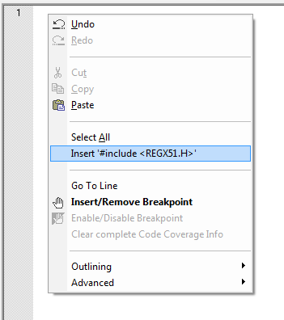

►Writing Hardware specific code
In harware specific code, we use hardware peripherals like ports, timers and uart etc. Do not forget to add header file for controller you are using, otherwise you will not be able to access registers related to peripherals.
Lets write a simple code to Blink LED on Port1, Pin1.
CODE:
#include <REGx51.h> //header file for 89C51
void main(){
//main function starts
unsigned int i;
//Initializing Port1 pin1
P1_1 = 0; //Make Pin1 o/p
while(1){
//Infinite loop main application
//comes here
for(i=0;i<1000;i++)
; //delay loop
P1_1 = ~P1_1;
//complement Port1.1
//this will blink LED connected on Port1.1
}
}

WORKING:-
A display is provided at the ground floor which is basically a counter that counts number of cars in each floor. It informs whether the floors are fully filled with the cars or is it having place in a particular floor or not. An indicator with a green and red LED is kept in all the floors to indicate whether the floor is free to accommodate car or not. If the red LED glows that means the floor has no space for any car to be parked. In this project we have provided three floors of a building for car parking. Maximum storage capacity of each floor is given as five. Storage capacity can be change
Any car can enter inside the car parking area. When the car enters, the sensors sense the car and counter value increases so that it can check whether any space is there or not. If there is space the car will enter inside indicating the place where the car can be parked on the lcd. If the GREEN led of all the floors glows it indicates there is a vacancy on each floor and the car can be parked on the ground floor. Similarly if the RED led of ground floor glows along with GREEN led of the other floors, it indicates no space for car parking on ground floor.
The place where the car can be parked is indicated on the lcd. Like for an example if the car can be parked on ground floor the lcd displays
“PARK CAR ON GROUND FLOOR”
Similarly if the car is to be parked on first floor the lcd displays
“PARK CAR ON FIRST FLOOR”
If there is no space for car to be parked, the lcd displays
“NO SPACE”
.

ADVANTAGES OF MULTI-STORY CAR PARKING:-

A city like Delhi has over five million cars and two-wheelers on its roads, but not enough parking spaces. The demand for parking space has, on an average in the main markets of Delhi, outstripped demand by 43 per cent. It is not just a problem of Delhi or Mumbai; all the big cities in India are facing the space crunch. Parking space is fast becoming a major issue in other cities like Kolkata, Bangalore, Hyderabad, Ahmedabad, Chandigarh, Pune and other urban and semi-urban cities.
Multi-storey car parks provide lower building cost per parking slot, as they typically require less building volume and less ground area than a conventional facility with the same capacity.
A multi-storey car parks offer greatest possible flexibility for the realization of optimum parking solution. Time-saving vertical and horizontal movements take place simultaneously ensuring fast parking and retrieval times.

DISADVANTAGES OF MULTI-STORY CAR PARKING:-
Drivers who use multi-story parking facilities, sometimes known as parking garages, often enjoy a number of benefits the structures provide. Despite the ability of the garages to house a large number of cars, multi-story parking facilities also carry a number of distinct disadvantages that arise from their tall, enclosed and often dimly lit nature.

1.Deterioration and Maintenance
Multi-story parking facilities support hundreds of thousands of pounds of vehicles, people and equipment every day. Because the garages support very large amounts of weight and loads that constantly change, the structures quickly deteriorate in the absence of constant maintenance activity. In addition, according to Canada's National Resource Council, changing weather and environmental conditions can deteriorate a garage's steel support structure, creating an unsafe environment for garage users. A number of corrosion inhibitors can help delay processes that eat away at the structure's integrity, according to the National Resource Council, but constant maintenance and upkeep must include anti-corrosion measures to keep multi-story parking facilities structurally sound.

2.Parking Angle Considerations
Because many drivers of varying levels of skills and experience drive in, around and out of parking garages every day, designers must pay special attention to the configuration of parking spaces within the structures. In a municipal parking garage presentation prepared by architects Sakri and Khairuddin, the designers noted that two-way traffic flow in a multi-story garage presents a number of parking challenges for drivers and designers. Parallel parking, for example, creates an inefficient use of limited space, while straight parking spaces make parking difficult for some drivers. Other options, like angled parking, do not work well with a two-way traffic flow and can only work well in garages with separate entrance and exit openings.
3.Lighting
While most parking lots open at night, multi-story or otherwise, require some form of lighting, the multi-story nature of parking garages creates a need for numerous lights throughout the structure. In addition, because the inside of the structure may remain dark even during the day, many of these lights must run at all times. This arrangement can create high energy bills for garage owners and may require frequent lighting maintenance to replace broken or burned-out bulbs.

4.Safety
Because multi-story parking facilities allow limited natural light inside, some security experts express concern about safety inside the structures. In their municipal presentation, architects Sakri and Khairuddin recommend security devices that directly connect to local police or public safety stations. In addition, the architects explicitly describe a need to reduce dark places where criminals may hide. Even with security measures in place, though, criminals still seem to thrive in multi-story parking structures; in a 2009 article in the Chicago Sun-Times, one parking garage user expressed frustration after experiencing three burglaries within two years.

APPLICATIONS:-
- Erection of multistoried car parking with surface car parking:-
It seeks permission for a larger multistoried car park and an amended parking layout to that approved.
- BERRY SYSTEMS:-
Berry system is an acknowledged UK market leader in the manufacture, design and installation of barrier protection systems for use in multistory car parks and industrial environments.
- Eastside multistoried car park
- Greenside multistoried car park
- Minories multistoried car park
- Woodhouse multistoried car park
- Manors multistoried car park
- Westgate multistoried car park
- Multistoried car park Poole

BIBLIOGRAPHY
- www.google.com
- Microcontroller 8051 and embedded systems by MAZIDI
- The 8051 microcontroller: hardware, software and interfacing by JAMES STEWART

